INVERTED PENDULUM

Table of Contents
1.0 Nonlinear system model of Inverted Pendulum 3
2.0 Analyzing the controllability, observability or stability of the above system 4
3.0 Designing Lyapunov Model for stability 7
4.0 Controller based feedback linearization model 11
5.0 Analysis of the controller design 13
Reference list 15

1.0 Nonlinear system model of Inverted Pendulum
The above project focuses on portraying the nonlinear system of an inverted pendulum. Basically inverted pendulum consists of “center of mass” on the point of pivot. An inverted pendulum is basically unstable in nature. As the inverted pendulum could fall from its position thus the usage of control system is highly required for monitoring pole’s angle as well as horizontal moving of pivot under “center of mass” for balancing it during falling. For testing the strategies of control, inverted pendulum plays a key role in the control theory. Basically inverted pendulum’s pivot point presented in a mounting position fixed within a cart (Fotuhi et al 2019). The below figure portrays the simulink model of a nonlinear system of an inverted pendulum. Basically the researcher designed the figure below using the MATLAB software and obtained the graph below as in the output. The researcher took the components from the “Simulink Library” and used those components to design this figure. The system of inverted pendulum is basically unstable in nature and it is significantly used in the implementation of the methods of control. Key objective related to above methods of control lies on moving the cart to its desired position relying on the stabilization of inverted pendulum in such a position upright in nature.

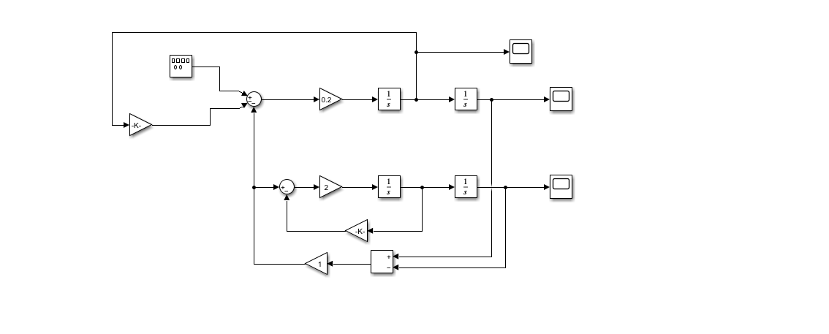
Figure 1: Simulink model of nonlinear system of an Inverted Pendulum
(Source: Self made in MATLAB)
The below figure is the graph obtained as output in MATLAB by the researcher based on designing the above model in the same software. The researcher studied about the nonlinear system and using the ideas obtained, focused on designing this model in MATLAB using the components and gets the output.

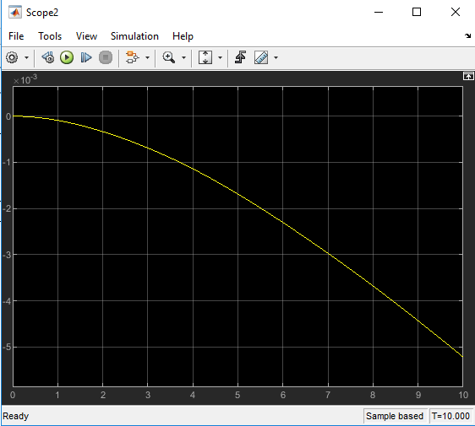
Figure 2: Graph of the Nonlinear system
(Source: Self made in MATLAB)

2.0 Analyzing the controllability, observability or stability of the above system
The above project emphasizes on designing the above nonlinear system model in the MATLAB and using the model for analyzing stability, observability and controllability associated with the above system. The researcher focuses on designing the model using the components and obtaining the output. To get a complete overview about how the system operates, the researcher needs to figure out whether the system is stable, observable or controllable in nature or not (Hazem et al 2020). Thus, the researcher wrote the codes in the MATLAB and obtained the matrices, which would portray the nature of the above system based on the stability, observability and controllability. 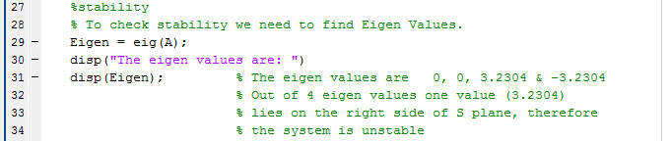
Figure 3: MATLAB Code for analyzing Stability
(Source: Self made in MATLAB)
Any system could be referred to as stable in case each of the constrained input deals with producing constrained output. The stability of any space-state model can be obtained in case every u(t) is bounded depending on the response x(t). The stability of any system could be analyzed based on the eigen values consisting of a real and negative part. The above figure is the code for analyzing stability in MATLAB.
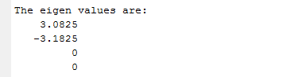
Figure 4: Eigen Values as Output
(Source: Self made in MATLAB)
As one of the eigen values consists of the real positive part as portrayed in the output in the above figure, this system proved to be unstable in nature.
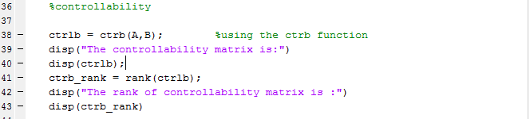
Figure 5: MATLAB Code for analyzing Controllability
(Source: Self made in MATLAB)
If the initial time (t0) of any system is possible and relies on the usage of “unconstrained vector of control” while transferring the system to any other state from its initial place within a given time interval, the system could be referred to as controllable. Again “the the matrix’s rank is similar to the rank of any nonsingular matrix, such as, [B AB A^2*B A^(n-1)*B] is 4, this system could be referred to as controllable” (Krishnan et al 2019). The researcher wrote the code for analyzing controllability in the MATLAB software and obtained a matrix having rank 4.

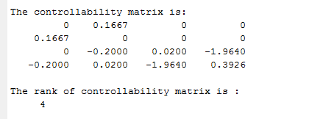
Figure 6: Controllability Matrix as Output
(Source: Self made in MATLAB)
The above figure depicts the matrix for controllability, which shows the above matrix’s rank. As the rank is 4, this system is controllable in nature.
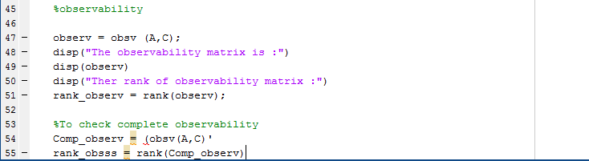
Figure 7: MATLAB Code for analyzing Observability
(Source: Self made in MATLAB)
The above figure portrays the code for checking the observability of the system while operating on MATLAB. The researcher wrote down the code in MATLAB for analyzing the system’s observability.

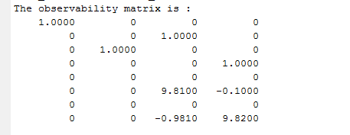
Figure 8: Observability Matrix as Output
(Source: Self made in MATLAB)
The figure above shows the matrix of observability for the above system. The rank is 4, thus making the system observable in nature.

3.0 Designing Lyapunov Model for stability

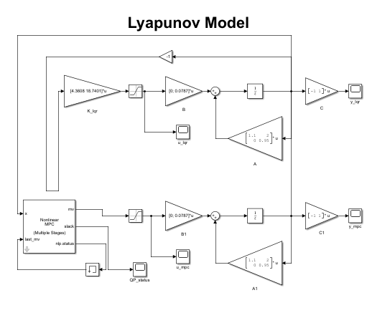
Figure 9: Lyapunov Model
(Source: Self made in MATLAB)
The differential equation’s solution deals with the several stabilities and relies on describing the dynamical systems. Out of the various stability types, the solution’s stability near to the equilibrium point is highly significant. The above figure depicts the Lyapunov model designed by the researcher in MATLAB. The Lyapunov method is significant for designing function’s stability (Rodriguez-Garavito et al 2018). The two methods proposed by the Lyapunov function are used for the demonstration of stability, the first one developing solution in series and convergence in nature in the limits and the second one, also referred as direct method, consists of classical dynamics based on potential function.

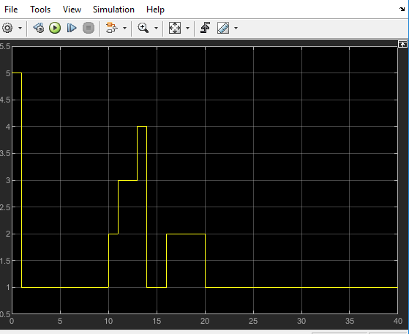
Figure 10: Output graph from Lyapunov Model
(Source: Self made in MATLAB)
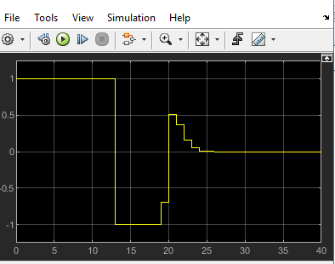
Figure 10: Output graph from Lyapunov Model
(Source: Self made in MATLAB)

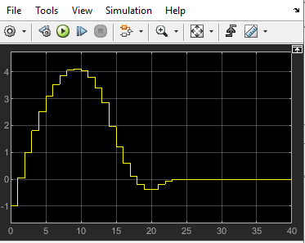
Figure 10: Output graph from Lyapunov Model
(Source: Self made in MATLAB)
The graph obtained from MATLAB relies on designing the Lyapunov model. The above model is designed based on Direct method of Lyapunov to check the stability of the above system. After designing the model, the researcher ran it and obtained the above graphs as output in MATLAB.
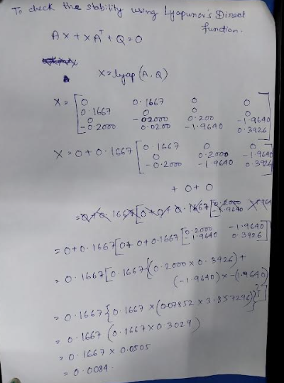
The above figure depicts the Lyapunov calculation for checking the level of stability of the above system. The Eigenvalue thus achieved is 0.0084, which is positive and real. Thus, the system is proved to be unstable in nature.

4.0 Controller based feedback linearization model
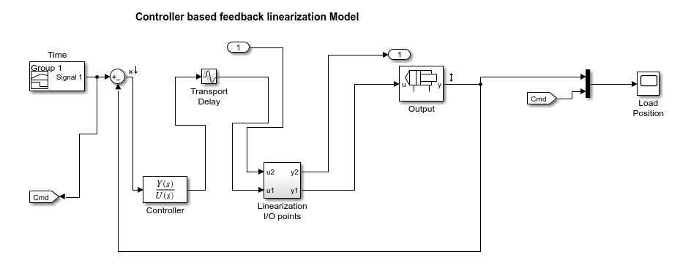
Figure 11: Controller Based feedback linearization Model
(Source: Self made in Matlab)
The above figure depicts the diagram of the controller based feedback linearization model. The project would discuss the “feedback linearization” theory along with designing its model in MATLAB. The above figure also discusses the control applications processes. “Feedback linearization” theory portrays the linear systems facilitating the results of nonlinear systems. The extension process deals with the process of multivariable and disturbances.
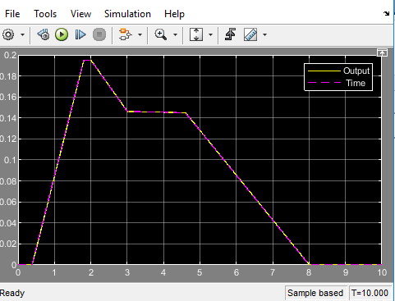
Figure 12: Output of the above feedback linearization model
(Source: Self made in Matlab)
The above graph was obtained from MATLAB by the researcher by designing the above model in the software. The researcher designed the model on the method of feedback linearization. The technique is highly significant for designing and analyzing the systems which are nonlinear in nature. The key idea behind using this technique lies in the transformation of nonlinear systems to linear ones (Patra et al 2022). Thus, the above model depicts how the “feedback linearization methods” could be used in making the above given system linear.
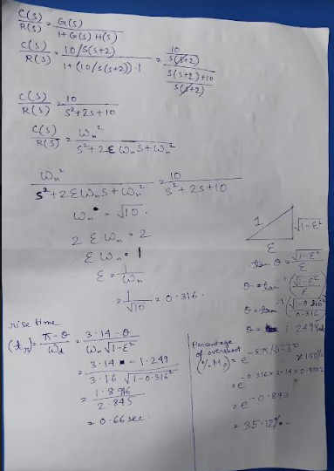
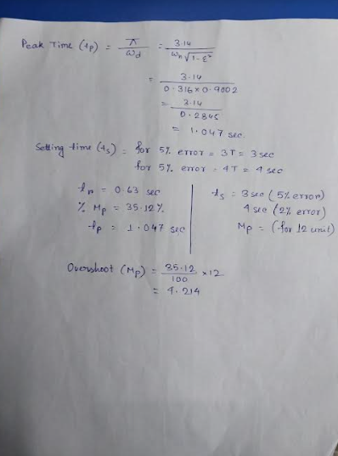
The above picture depicts the calculation to calculate the rise time, overshoot, peak time and the maximum setting time for the above design. The researcher calculated the above by using the respective formulas.

5.0 Analysis of the controller design
The control strategies of “Feedback Linearization '' relies on the insight of dynamic and kinematic parameters associated with the manipulator for obtaining the suitable results. The researcher in this project uses a signal and a controller as the components for the linearization of the above nonlinear model. The linear I/O points are thus used in order to linearize the above model and the graph thus obtained in the output (Jain et al 2021). The graph obtained in the output portrayed above system is linearized based on the model of “Feedback linearization”.
By comparing the above system with the given system, it can be concluded that this system would be more stable based on the calculated values. The values obtained are shown in the manual calculation and thus making the above system more stable.

Reference list
Journal
Fotuhi, M.J., Hazem, Z.B. and Bingül, Z., 2019, October. Modelling and torque control of an non-linear friction inverted pendulum driven with a rotary series elastic actuator. In 2019 3rd International Symposium on Multidisciplinary Studies and Innovative Technologies (ISMSIT) (pp. 1-6). IEEE.
Hazem, Z.B., Fotuhi, M.J. and Bingül, Z., 2020. A comparative study of the joint neuro-fuzzy friction models for a triple link rotary inverted pendulum. Ieee Access, 8, pp.49066-49078.
Jain, A., Sharma, A., Jately, V., Azzopardi, B. and Choudhury, S., 2021. Real-time swing-up control of non-linear inverted pendulum using Lyapunov based optimized fuzzy logic control. IEEE Access, 9, pp.50715-50726.
Krishnan, A., Singh, R. and Goyal, V., 2019, July. Non-linear Dynamical Analysis of an Inverted Pendulum Cart Mechanism using Bifurcation Method. In 2019 2nd International Conference on Intelligent Computing, Instrumentation and Control Technologies (ICICICT) (Vol. 1, pp. 466-471). IEEE.
Patra, A.K., Biswal, S.S. and Rout, P.K., 2022. Backstepping linear quadratic gaussian controller design for balancing an inverted pendulum. IETE Journal of Research, 68(1), pp.150-164.
Rodriguez-Garavito, C.H., Arevalo-Castiblanco, M.F. and Patiño-Forero, A.A., 2018, June. Implementation of a non-linear fuzzy Takagi-Sugeno controller applied to a mobile inverted pendulum. In The 13th International Conference on Soft Computing Models in Industrial and Environmental Applications (pp. 344-353). Springer, Cham.

